OCTO CONSULTING GROUP

Test Report

**For eLAB Program (Sentinel Prelog v1.0)**

Version 1.0

March 25, 2016



Prepared by:

Octo Consulting Group

1600 International Drive, 5th Floor

McLean, VA 22102

**SIGNATURES/APPROVALS**

|  |  |  |
| --- | --- | --- |
|  |  |  |
|  |  |  |
|  |  |  |
|  |  |  |
|  |  |  |
| Patricia Wilson  Program Manager  eLAB Unit  IT Customer Relationship & Management Division |  | Date |
|  |  |  |
|  |  |  |
|  |  |  |
| Liza Krieger  Deputy Program Manager  eLAB PMO  FBI Laboratory |  | Date |

Change Description Form

|  |  |  |  |  |
| --- | --- | --- | --- | --- |
| **Revision** | **Change Description** | **Changed By** | **Date** | **Approved By** |
| 1.0 | Initial release | E. Hosler | 03/14/2016 |  |
|  |  |  |  |  |
|  |  |  |  |  |

Table of Contents

1.0 SCOPE 1

1.1 Identification 1

1.2 Document Overview 1

2.0 REFERENCED DOCUMENTS 1

3.0 OVERVIEW OF TEST RESULTS 1

3.1 System Description 2

3.2 Impact of Test Environment 3

3.3 Recommended Improvements 3

4.0 DETAILED TEST RESULTS 4

4.1 Problems Encountered 4

4.2 Deviations from Test Cases/Procedures 5

4.3 Variances 6

4.4 Comprehensiveness 6

5.0 TEST LOG 6

6.0 ACROYNM LIST 7

7.0 APPENDICIES 8

7.1 Appendix A – Testing Results List 8

**Tables:**

Table 1: Referenced Documents 1

Table 2: eLAB Test Prelog API v1.0 Results Overview 1

Table 3: Octo Testing Environments Virtual Machines 2

Table 4: Octo Testing Environments Software 3

Table 5: Issue Severity Levels 4

Figures:

Figure 1: Octo Testing Environments 4

1. SCOPE
   1. Identification

This document refers to the execution of the Federal Bureau of Investigation (FBI) Electronic Laboratory (eLAB) Forensic Advantage® Laboratory Information Management System (FA LIMS) Sentinel Prelog API v1.0 release testing cycle and provides a summary of the test results. This testing cycle was conducted on Forensic Advantage (FA) software version 15.1 and with Prelog API v1.0.

* 1. Document Overview

The purpose of this document is to formally report the test results and issues found during the Sentinel Prelog API v1.0 release testing cycle. The test results include all items tested, validation steps, expected results, and pass/fail status. The completed test cases, which include detailed test execution and validation steps, will be maintained as separate documents.

1. REFERENCED DOCUMENTS

The Octo Test Team referenced the following documents during the development of Sentinel Prelog API v1.0 Release Test Report:

**Table 1: Referenced Documents**

| **Title** | **Revision** | **Date** |
| --- | --- | --- |
| eLAB Requirements Traceability Matrix | v15.1 Release | 03/25/2016 |
| eLAB Sentinel Prelog API v1.0 Release Test Cases | 1.0 | 03/25/2016 |
| eLAB System Requirements Specification (SRS) | 1.14 | 11/3/2015 |
| eLAB Sentinel Prelog API v1.0 1 Release Notes | 1.0 | 03/25/2016 |

1. OVERVIEW OF TEST RESULTS

The Sentinel Prelog API v1.0 release testing cycle was conducted using the Forensic Advantage software v15.1 and with Prelog API v1.0. Testing identified defects reported during Octo internal testing and with Sentinel integration, testing, and testing of applicable System Requirements Specifications (SRS) requirements.

**Table 2: eLAB Test Prelog API v1.0 Results Overview**

| **Test Category** | **Description** | **Quantity** | **Results** |
| --- | --- | --- | --- |
| SRS Requirements | 7.18 | 1 SRS | Pass |

A total of 5 test cases were executed during the Sentinel Prelog API v1.0 release testing cycle. A total of 5 test cases passed. There is not a one-to-one relationship between the items reported in Table 2: eLAB Prelog API v1.0 Test Results Overview and the number of test cases executed. Testing items were combined into one test case where applicable. Refer to Section 5.0 Test Log for specific information on each test case.

* 1. System Description

The eLAB Sentinel Prelog API v1.0 release testing occurred in the Octo Test environment in McLean, VA, the FBI Primrose environment located in Crystal City, VA and the FBI Security Division (SEC-D) Closed Laboratory in Washington D.C. Due to the inaccessibility of information that supports both FBI testing environments, the scope of this section is limited to the environment that Octo manages. Additional information requests for the FBI Primrose or the SEC-D Closed Laboratory should be directed to the respective responsible FBI entity.

The Octo testing infrastructure was comprised of one distinct environment in which testing occurred and utilized the database for the Octo Test environment.

The Octo Test environment is managed by the Octo staff and employs security guidance from Defense Information Systems Agency (DISA) Security Technical Information Guidelines (STIGs) and the eLAB Information System Security Officer (ISSO). The test infrastructure is supported by the FAS/Commercial Off-The-Shelf (COTS) development environment and a change and release management process.

The Octo Test environment in McLean, VA contains a single physical Dell server running Citrix Xen Server. Xen Server is Citrix’s hypervisor, which allows the physical hardware, i.e. the host, to be virtualized and used by multiple virtual servers. The virtualized server contains virtual machines running Windows and the required software including Forensic Advantage (FA), and the Prelog API. The virtual machines running on Xen Server closely resemble that of the Pretest, GAT and Production environments: Active Directory, application servers, SQL servers, VDI in a Box and virtual desktops.

Dedicated CISCO ASA 5505 and Catalyst 1950 network appliances for data transportation support the Octo McLean environments. The following tables and figure summarize the virtual machines in the Octo Testing environment.

**Table 3: Octo Testing Environments Virtual Machines**

| **Virtual Machine** | **Purpose** | **Software** |
| --- | --- | --- |
| ELABDC01 | Active Directory | Windows Server 2008 R2 |
| ELABDC02 | Active Directory | Windows Server 2008 R2 |
| TestSQL01 | SQL Server Node 1 for Test | Windows Server 2008 R2  SQL Server 2012 SP3 |
| TestSQL02 | SQL Server Node 2 for Test | Windows Server 2008 R2  SQL Server 2012 SP3 |
| TestApp01 | Application Server Node 1 for Test | Windows Server 2008 R2  Forensic Advantage |
| TestApp02 | Application Server Node 2 for Test | Windows Server 2008 R2  Forensic Advantage |
| Elabxen01 | Xen Server | Citrix Xen Server |
| Elabxen02 | Xen Server | Citrix Xen Server |
| SharePoint | SharePoint for 1A | Windows Server 2008 R2 |
| Sentinel01 | Dedicated server running the Prelog v1.0 software | Windows Server 2012 R2 |

**Table 4: Octo Testing Environments Software**

|  |  |
| --- | --- |
| **Software** | **Purpose** |
| Windows Server 2008 R2 x64  Windows Server 2012 R2 x64 | The operating system (OS) for the server. |
| Dot Net 4.0 Framework | This is an integral part of many applications running on Windows and provides common functionality for the application to run. |
| SQL Server 2012 Enterprise | The database service application. |
| Forensic Advantage (FA) version 15.1 | The LIMS software. |
| Adobe Reader | Read PDFs |
| Microsoft Office 2013 | Compatibility with production |
| Sentinel Prelog API version 1.0 | The Prelog software |

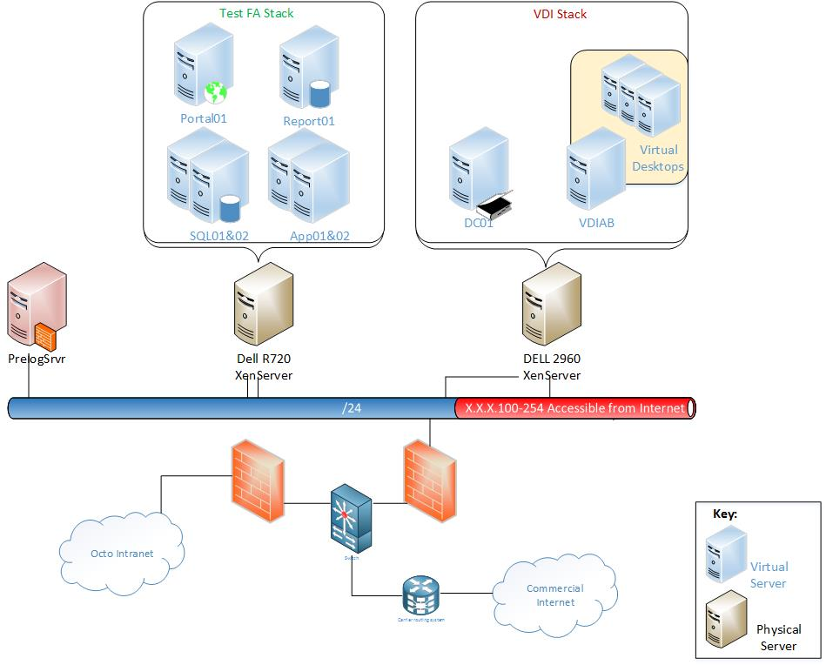

**Figure 1: Octo Testing Environments**

* 1. Impact of Test Environment

None.

* 1. Recommended Improvements

None.

1. DETAILED TEST RESULTS
   1. Problems Encountered

The Octo Test Team leveraged the severity and priority levels displayed in **Table 5: Issue Severity Levels** to categorize issues encountered during the Sentinel Prelog API v1.0 release testing cycle.

**Table 5: Issue Severity Levels**

| **Severity and Priority** | **Assumptions** |
| --- | --- |
| **Defect Severity 1 Definition**   * Total system failure or system component failure resulting in data loss. * Causes critical impact to business operations if service is not restored quickly. * No workaround available.   **Priority**   * Priority 1: Requires acknowledgement and mitigation by the Contractor within two (2) days, or forty-eight hours. * Priority 2: Requires mitigation in the next possible FA release. * Priority 3: Submitted to the vendor as ‘nice to have’ and addressed when possible in an FA release.   **Note:** Severity 1 defects identified during Octo testing shall be mitigated before Gold Disk delivery to the FBI. Severity 1 defects identified during FBI testing shall be mitigated before Quantico production deployment. | Priority 1 defects will be acknowledged and mitigated within two business days, unless an alternative timeframe is approved by the FBI PMO. |
| **Defect Severity 2 Definition**   * Total system failure or system component failure resulting in no data loss. * Causes critical impact to business operations if service is not restored quickly. * Workaround is available. However, defect triage discussions lead to FBI determination that the workaround is high in severity and is not a viable option due to impact on users and/or business operations. In the case that a decision cannot be resolved during defect triage, FBI executive sponsor may be included to help determine.   **Priority**   * Priority 1: Requires acknowledgement and mitigation by the Contractor within two (2) days, or forty-eight hours. * Priority 2: Requires mitigation in the next possible FA release. * Priority 3: Submitted to the vendor as ‘nice to have’ and addressed when possible in an FA release.   **Note:** Severity 2 defects identified during Octo testing shall be mitigated before Gold Disk delivery to the FBI. Severity 1 defects identified during FBI testing shall be mitigated before Quantico production deployment. | Priority 1 defects will be acknowledged and mitigated within two business days, unless an alternative timeframe is approved by the FBI PMO. |
| **Defect Severity 3 Definition**   * System functionality is degraded, no failures or data loss is experienced. * Component functionality does not meet decomposed requirement(s). * Workaround available.   **Priority**   * Priority 1: Requires acknowledgement and mitigation by the Contractor within two (2) days, or forty-eight hours. * Priority 2: Requires mitigation in the next possible FA release. * Priority 3: Submitted to the vendor as ‘nice to have’ and addressed when possible in an FA release.   **Note:** Severity 3 defects identified during Octo or FBI testing shall be reviewed and triaged with the FBI for prioritization before Quantico production deployment. | Severity 3 defects that are assigned Priority 1 will not be remediated in two business days. A timeframe for resolution will be negotiated between Team Octo and the FBI PMO.  A workaround or explanation is available to be defined as Severity 3. |
| **Defect Severity 4 Definition**   * System functionality is not impacted. * Defect is minor in scope, cosmetic, and/or non-functional. * Customer or end customer requires information or assistance on software capabilities, installation, or configuration. * Workaround available.   **Priority**   * Priority 1: Requires acknowledgement and mitigation by the Contractor within two (2) days, or forty-eight hours. * Priority 2: Requires mitigation in the next possible FA release. * Priority 3: Submitted to the vendor as ‘nice to have’ and addressed when possible in an FA release.   **Note:** Severity 4 defects identified during Octo or FBI testing shall be reviewed and triaged with the FBI for prioritization before Quantico production deployment. | Severity 4 defects will never be classified as Priority 1.  A workaround is not likely to be available for cosmetic or non-functional defects. |

No issues encountered during the Sentinel Prelog API v1.0 release testing cycle remain outstanding.

* 1. Deviations from Test Cases/Procedures

During the Sentinel Prelog API v1.0 release test cycle, two configuration deviations were noted in order to successfully test the entirety of the Prelog API software. Those deviations include the items listed in the following table.

**Table 6: Sentinel Prelog API v1.0 release Deviations**

| **Item #** | **Summary** | **Issue Description** | **Change Required in PROD** |
| --- | --- | --- | --- |
| 1 | Change Case Record “Set Status Manually” settings to allow for testing. | In order to test displaying the proper status in Sentinel for all possible Case Record Statuses, the FA Core Application settings were updated to allow the manual transition to each of the statuses. The following statuses were changed for testing.   * Backlog - Waiting for Evidence * Backlog - Evidence Available * Exam in Process * Exam Finished * Case Note Data Entered * Report in Process * Review Required * Review in Process * Pending Release * Merged Report * Complete * Amended | No |
| 2 | Change POI Type for Business of Interest to allow for submission from Sentinel. | Sentinel submits Business of Interests as a POI type of “Party of Interest”. The FA Core Application settings were updated to allow the use of the POI type for Business of Interest.  Setting changed:  Admin Tab | System Data | Submission | POIRelationship   |  |  |  | | --- | --- | --- | | **Code** | **Description** | **ForBusiness** | | P | Party of Interest | Checked | | Yes |

* 1. Variances

Variances occur when the Sentinel Prelog API v1.0 release requirements are not fully met by the API software as stated, an enhancement to the existing requirement is requested by the FBI, or an issue is identified through ad-hoc testing. There were no variances identified during the Sentinel Prelog API v1.0 testing cycle.

* 1. Comprehensiveness

The Octo Test Team conducted thorough functional testing to ensure the approved requirements as stated in the FBI eLAB Requirements Traceability Matrix were met in eLAB Sentinel Prelog API v1.0 release. Throughout the configuration and testing cycle, the team updated and maintained a detailed Requirements Traceability Matrix (RTM) mapping the FBI eLAB System Requirements to test cases with a corresponding pass/fail status. Upon completion of the testing cycle, the Octo Test Team produced a detailed Test Report, an updated RTM, test cases, combined release notes, and a testing results list.

The Octo Test Team conducted functional requirements based testing to ensure that the business and operational processes were met by the functional components of the FA system. The Sentinel Prelog API v1.0 release testing cycle focused on positive Black Box testing including some negative branching (such as error message handling, boundaries and/or limits placed on fields and other validation rules).

1. TEST LOG

Of the 5 test cases, 5 passed during the Sentinel Prelog API v1.0 release testing cycle. The following table summarizes the test cases executed during the Sentinel Prelog API v1.0 release testing cycle. Each table includes the test case name, the reason for testing, the test date, and the completion status.

**Table 8: New Test Case Log**

| **Test Case** | **Reason for Test** | **Date(s)** | **Completion Status** |
| --- | --- | --- | --- |
| TC-166.0 Sentinel Prelog requests can be deleted | SRS | 03/10/2016 | Pass |
| TC-166.2 Sentinel Prelog-Create Submission | SRS | 03/10/2016 | Pass |
| TC-166.3 Sentinel Prelog-Data Translations | SRS | 03/10/2016 | Pass |
| TC-166.4 Sentinel Prelog-Filter Case Records | SRS | 03/10/2016 | Pass |
| TC-166.5 Sentinel Prelog-Get Case Record Data | SRS | 03/10/2016 | Pass |

1. ACROYNM LIST

| Acronym | Description |
| --- | --- |
| CONOPS | Concept of Operations |
| COTS | Commercial Off-The-Shelf |
| CR | Change Request |
| DIST | Defense Information Systems Agency |
| DRAC | Dell Remote Access Controller |
| eLAB | Electronic Laboratory |
| FA | Forensic Advantage® |
| FAS | Forensic Advantage® Systems |
| FBI | Federal Bureau of Investigation |
| GAT | Government Acceptance Testing |
| ISSO | Information System Security Officer |
| ITSD | Information Technology Services Division |
| LIMS | Laboratory Information Management System |
| OS | Operating System |
| PCA | Physical Configuration Audit |
| PM | Project Manager |
| PMO | Program Management Office |
| RT | Regression Test |
| RTM | Requirements Traceability Matrix |
| SQL | Structured Query Language |
| SRS | System Requirements Specification |
| STaCS | Sample Tracking and Control Software |
| STIG | Information Assurance Support Environment |
| TC | Test Case |
| UAT | User Acceptance Testing |
| VDI | Virtual Desktop Image |
| VIAB | VDI in a Box |

1. APPENDICIES
   1. Appendix A – Testing Results List

| **Item #** | **Summary** | **Issue Description** | **Resolution** |
| --- | --- | --- | --- |
| 1 | Missing Data Elements | Prelog WSDL data elements were missing from the API software. These Data elements were needed to document related case numbers and LER document information from Sentinel. | New build of the API was produced to include missing data elements. |
| 2 | Incorrect required fields | When submitting a new Prelog request, data fields in the API were required where no data was being supplied. | New build of the API was produced to include removing the required fields so that the Prelog request could be successfully submitted. |
| 3 | Submissions that include evidence cannot be imported into the FA application | Evidence ordering and sorting on the resulting submission report caused application errors during RFLE import. | New build of the API was produced to correct the evidence sorting issue within the RFLE report. |
| 4 | Submission fails when supplying officer information | In requests that required officer information, the request could not be validated or submitted. | New build of the API was produced that corrected the officer inclusion issue. Analysis indicated there was a domain mapping issue which was resolved with this build. |
| 5 | Case Record Status not translated on status request | Case Record status was being relayed at first as a single status no matter what status was applied in the FA Client. After resolution of that issue, the Case Record status was being relayed as displayed in the FA Client without any translation, which is required for Sentinel UI display. | New build of the API was produced that corrected the translation issue within the API code. |
| 6 | RFLE Serial Number Not returned | When getting status for case record, case, and submission, the RFLESerailNumber in the ForensicCaseInfo.Record[] list is not returned. | New build of the API was produced that corrected the output of the status requests so that the RFLE Serial Number is returned in the result set. |
| 7 | Get Status results mapping error | When making this request the API throws a mapping error because case, case record, and submission status elements are empty. | New build of the API was produced that corrected the output of the status requests so that Case, Case Record, and Submission Status elements are properly populated with the respective data. |
| 8 | Agency Location IDs not mapping | OrgUnitIDs are supplied through the API and are not being translated through the API to the respective FA OrgIDs. | New build of the API was produced that corrected a SQL issue with the ID mapping table. |
| 9 | API Fields not mapping correctly | Information contained within the FA case, case record, and submission is not being properly displayed in the response to Sentinel. | New build of the API was produced that corrected the mapping issues with the AgencyAddressId, AgnecyLocationId, and ExamType data elements in the status result set. |
| 10 | Exam Type descriptions not being displayed | In the response object for the submission status request, the exam type code was being provided instead of the exam type description. | The SQL stored procedure that populated the exam type data element in the submission status response object was updated to provide the exam type description. |
| 11 | Submissions fail when providing evidence without barcodes | The Verify and Submit process required the evidence items to have a barcode supplied in the respective data element. When left blank, the Verify and Submit processes failed. | New build of the API was produced that corrected the issue by suppressing the error that resulted from not supplying a barcode. Suppressing the error allowed the process to complete and the submission be sent through the API. |
| 12 | Evidence ID and Barcode not properly separated by a space. | When displaying submitted evidence data, the evidence number and barcode must be separated by a space after the comma. | The API configuration file was updated so that the format of the displayed data included the required space. |
| 13 | Prelog data within Sentinel does not pull the correct submission when requested. | Testing identified an issue where the RFLE serial number was not being properly tracked for subsequent submissions and case record links. This issue resulted in submission status displays in Sentinel not properly aligning to their respective FA submission. | An extra extended data element was added to the Submission_XP screen to link the submissions to the Sentinel RFLE Serial ID. The API was updated to handle the additional extended data element and to properly link FA and Sentinel Submissions. |
| 14 | Multiple Lead numbers within Submissions | When supplying multiple lead numbers through the Prelog API, the API selects the first Lead number assigned for tracking. In some cases, the tracked Lead number is not the one designated for the Laboratory, which creates incorrect Lead links. | Sentinel is filtering the Lead Number that is sent to the Laboratory to the ones meant for the Lab. Only one Lead Number will be sent to the Laboratory for each RFLE submission. |